**AI Chemist: Pioneering the Future of Chemical Science with Gemini Vision Pro**

**INTRODUCTION**

AI Chemist is an innovative mobile application designed to deliver tailored chemical solutions and experimental recommendations through the advanced Gemini Pro model. By leveraging artificial intelligence, this app assesses user input, laboratory conditions, and research objectives to provide customized experiment designs, chemical synthesis pathways, and insightful data analysis. The primary aim of AI Chemist is to enhance efficiency and drive innovation in chemical research by offering intelligent, data-driven guidance and support.

In the context of pharmaceutical research, Dr. Alvarez, a 35-year-old researcher, is working on developing a new drug to combat a resistant bacterial strain. She inputs the target bacterial enzymes and chemical structures she wishes to explore into AI Chemist. The app analyzes this information and suggests several potential compounds along with synthetic pathways. Dr. Alvarez synthesizes these compounds in her lab, utilizing AI Chemist’s real-time monitoring to adjust reaction conditions dynamically. The app provides feedback on yield and purity, offering further refinements, thereby accelerating her research and helping her identify the most promising drug candidates efficiently.

In another scenario focused on green chemistry, James, a 40-year-old environmental chemist, is developing an eco-friendly pesticide. He inputs the desired properties of the pesticide along with environmental constraints into AI Chemist. The app generates a list of potential compounds and suggests environmentally benign synthesis methods. James uses AI Chemist to monitor reactions in real-time, ensuring that the processes minimize waste and energy consumption. The app also provides insights into the biodegradability and toxicity of the products, helping James develop a sustainable pesticide that meets regulatory standards and is safe for the environment.

In the field of polymer science, Dr. Liu, a 32-year-old materials scientist, is working on creating a new polymer with high tensile strength for aerospace applications. She inputs the required mechanical properties and chemical stability parameters into AI Chemist. The app suggests various monomers and polymerization techniques, which Dr. Liu follows to synthesize the polymers in her lab. AI Chemist’s real-time monitoring capabilities enable her to adjust reaction parameters to optimize the polymer's properties. The app provides immediate feedback on tensile strength and thermal stability, allowing Dr. Liu to iterate quickly and achieve the desired material characteristics.

**PROJECT FLOW**

The user interacts with the user interface (UI) to provide input. This input is then collected from the UI and transmitted to the backend using the Google API key. The input is subsequently forwarded to the Gemini Pro pre-trained model through an API call. The Gemini Pro model processes the input and generates an output, which is then sent back to the frontend for formatting and display.

To achieve this, the following activities must be completed:

1. **Requirements Specification**:
   * Create a requirements.txt file to list all the necessary libraries.
   * Install the required libraries.
2. **Initialization of Google API Key**:
   * Generate the Google API Key.
   * Initialize the Google API Key for use in the application.
3. **Interfacing with the Pre-trained Model**:
   * Load the Gemini Pro pre-trained model.
   * Implement a function to retrieve responses from the Gemini model.
   * Develop a function to read and process PDF content.
   * Write a prompt for the Gemini model.
4. **Model Deployment**:
   * Integrate the application with a web framework.
   * Host the application for public or internal use.

**PROJECT STRUCTURE**

Create the project folder with the following structure:

* images folder: This folder is designated to store the images used in the user interface.
* .env file: This file securely stores the Google API key.
* app.py: This is the main application file, containing both the model and the Streamlit UI code.
* requirements.txt: This file lists all the necessary libraries that need to be installed for the application to function correctly.

Additionally, ensure that files are well-organized and follow best practices for version control.

**REQUIREMENTS SPECIFICATION**

Specifying the necessary libraries in the requirements.txt file ensures a smooth setup and reproducibility of the project environment, making it simpler for others to replicate the development environment.

**Create a requirements.txt file to list the required libraries.**

* streamlit: A powerful framework for building interactive web applications using Python.
* streamlit_extras: Provides additional utilities and enhancements for Streamlit applications.
* google-generativeai: A Python client library for accessing the GenerativeAI API, enabling interactions with pre-trained language models like Gemini Pro.
* python-dotenv: Facilitates the management of environment variables stored in a .env file for Python projects.
* PyPDF2: A Python library for extracting text and manipulating PDF documents.
* Pillow: A fork of the Python Imaging Library (PIL) that supports opening, manipulating, and saving various image file formats

**Install the required libraries**

* Open the terminal.
* Run the command: pip install -r requirements.txt
* This command installs all the libraries listed in the requirements.txt file

**Initialization of Google API Key**

The Google API key is a secure access token provided by Google, allowing developers to authenticate and interact with various Google APIs. It serves as an identification tool, granting users access to specific Google services and resources. This key is essential for authorizing and securing API requests, ensuring that only authorized users can access and use Google's services.

* Create a .env file and define a variable named GOOGLE_API_KEY.
* Assign the copied Google API key to this variable.
* Paste the API key obtained from the previous steps here.

**Interfacing with Pre-trained Model**

To interface with the pre-trained model, we'll start by creating an app.py file, which will contain both the model and Streamlit UI code.

**Load the Gemini Pro API**

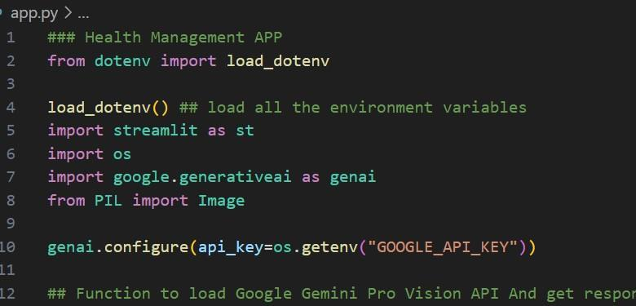

This code snippet is used to initialize a health management application with Streamlit, an open-source app framework, and Google Generative AI services. The script begins by loading environment variables from a `. env` file using the `load_dotenv()` function from the `dotenv` package. It then imports the required libraries: `streamlit` for building the web app interface, `os` for accessing environment variables, `google.generativeai` for leveraging Google's Generative AI capabilities, and `PIL.Image` for image processing. The `genai.configure()` function is called to set up the Google Generative AI API using the API key retrieved from the environment variables, ensuring secure and authorized access to the AI services.

**Implement a function to get gemini response**

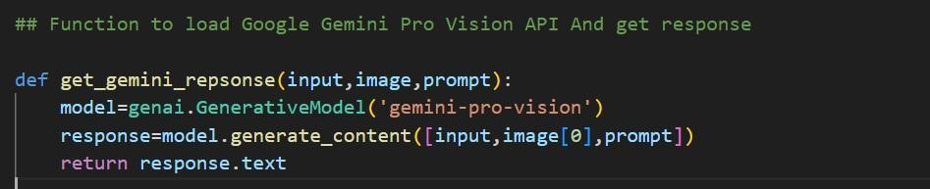

* The function get_gemini_response takes an input text as a parameter.
* It calls the generate_content method of the model object to generate a response.
* The generated response is returned as text.

Implement a function to read the Image and set the image format for Gemini Pro model Input

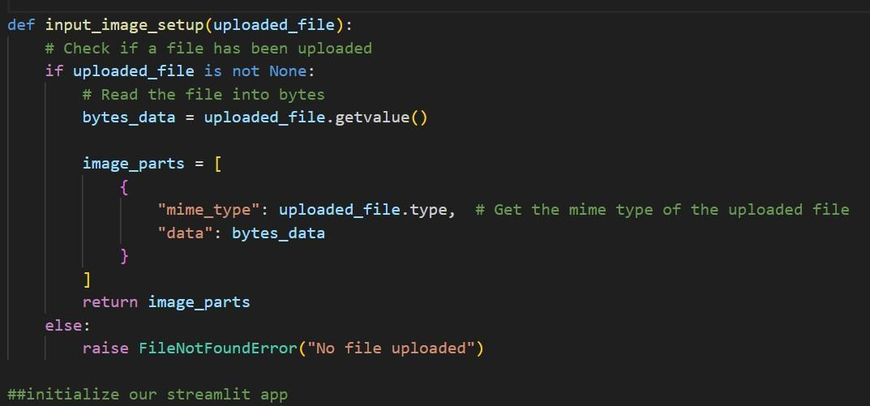

The `input_image_setup` function handles the processing of an uploaded image file for a health management application. It begins by checking whether a file has been uploaded. If a file is present, it reads the file’s content into bytes and creates a dictionary containing the file’s MIME type and byte data. This dictionary is then added to a list called `image_parts`, which the function returns. If no file is uploaded, the function raises a `FileNotFoundError`, indicating that an image file is required but was not provided. This approach ensures that the uploaded image is properly formatted and prepared for further processing or analysis within the application.

**Write a prompt for gemini model**

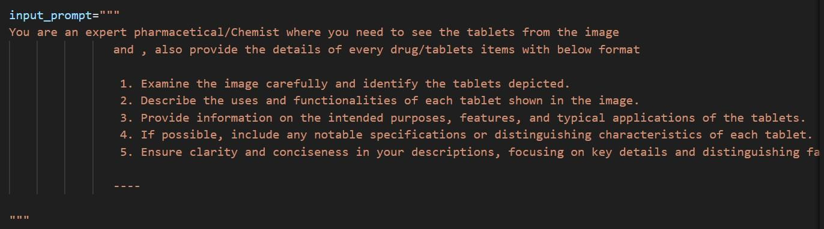

The `input_prompt` variable is a multi-line string crafted as a prompt for a nutritionist AI model. It directs the model to analyze an image of food items, identify each item, and calculate the total calorie count. Furthermore, the model is expected to provide a detailed breakdown of each food item with its corresponding calorie content. The output should be presented as a numbered list, with each item and its calorie information clearly displayed, ensuring organized and understandable data for the user. This prompt is intended for use with an AI service capable of processing images and generating nutritional information based on the provided visual data.

**METHODOLOGY**

**Conceptualization and Design**: The AI Chemist application is designed to revolutionize chemical research by integrating advanced AI capabilities with user-friendly interaction models. The first step involves defining the key requirements of the system, identifying the intended audience, and conceptualizing how the app will interact with users. The focus is on creating a seamless experience where researchers can input data easily, receive real-time feedback, and make data-driven decisions. This is achieved through careful planning of the application's architecture, UI design, and the underlying AI models, ensuring that the system is both functional and intuitive. The design includes a responsive front-end using Streamlit and a robust back-end powered by the Gemini Pro model, supported by APIs to handle complex computations and analyses efficiently.

**Integration of AI and Data Processing Models:** The core of AI Chemist lies in its ability to interpret complex inputs, generate experimental designs, and provide insightful recommendations. The integration of the Gemini Pro model is central to achieving these capabilities. The model is pre-trained on vast datasets related to chemical synthesis, pharmaceutical research, and material science, allowing it to generate accurate and relevant outputs based on user input. The data processing component involves implementing functions that handle different types of data, such as text, chemical structures, and images, making the model versatile across various research domains. The process begins with loading the Gemini Pro model via an API, followed by defining custom functions that facilitate communication between the user input and the model, such as the get_gemini_response and input_image_setup functions.

**User Interaction and Real-time Feedback**: The user interface (UI) is designed using Streamlit, a popular Python framework for building interactive applications. Streamlit's simplicity and flexibility allow researchers to input data in various formats, including text, chemical structures, and images, and receive real-time feedback. The AI Chemist UI collects user inputs, processes them using the Gemini Pro model, and displays the results in a user-friendly format. Real-time monitoring is a critical feature, enabling users like Dr. Alvarez to dynamically adjust reaction conditions based on the app's feedback. This interactive approach significantly enhances research efficiency by reducing trial-and-error and providing immediate insights into experimental progress, such as yield, purity, and compound stability.

**Secure API Integration and Data Management:** The application uses the Google GenerativeAI library to securely connect to the Gemini Pro model via the Google API key, which is stored in a .env file for secure access management. This key facilitates the authentication and authorization of API requests, ensuring that only legitimate users can access the system's advanced features. The .env file setup is critical to protecting sensitive information and maintaining the integrity of the API integration. Additionally, the data management strategy includes using the PyPDF2 and Pillow libraries for reading and processing PDF documents and images, allowing the app to extract and analyze complex data types that are common in chemical research. This modular approach to data handling ensures that the app can manage a variety of input formats seamlessly.

**Model Deployment and Public Access:** Deploying the AI Chemist application involves integrating the backend AI model with a web framework like Streamlit, making the tool accessible to researchers worldwide. The deployment process includes hosting the app on a cloud platform, which provides scalability and ease of access. To ensure smooth operation, a robust requirements specification is implemented through a requirements.txt file, which lists all necessary libraries, including streamlit, google-generativeai, and others. This approach simplifies the setup process for new users, allowing them to replicate the development environment with minimal effort. The deployed application is designed to offer an engaging and supportive environment where researchers can explore new chemical pathways, optimize reaction conditions, and receive valuable insights that drive their work forward.

This methodology emphasizes a comprehensive, user-centered approach to integrating AI into chemical research, ensuring that AI Chemist remains at the forefront of scientific innovation.

**LITERATURE SURVEY**

**Advances in AI-driven Chemical Research:** The use of artificial intelligence (AI) in chemical research has grown significantly in recent years, driven by the need to accelerate discovery and enhance the efficiency of experimental design. Traditional chemical research relies heavily on trial-and-error methods, which can be time-consuming and costly. AI technologies, particularly machine learning (ML) and deep learning (DL), have been successfully applied to predict molecular properties, optimize reaction conditions, and design novel compounds. The integration of AI tools in chemical synthesis has led to the development of predictive models that suggest synthetic routes based on vast amounts of historical data, making it possible to explore previously uncharted chemical spaces. This trend is evidenced by various studies where AI has been used to automate tasks like retrosynthesis, reaction prediction, and structure-property relationship modeling, thus pushing the boundaries of chemical science.

**Application of AI in Pharmaceutical Research:** AI has significantly impacted pharmaceutical research, particularly in the areas of drug discovery and development. AI algorithms can analyze complex biological data to identify potential drug targets, predict the activity of new compounds, and optimize their properties for therapeutic use. Studies have shown that AI-driven platforms can reduce the time and cost associated with the drug discovery process by rapidly screening millions of compounds and identifying those most likely to succeed in clinical trials. Applications such as AlphaFold, which predicts protein structures, have demonstrated the immense potential of AI in understanding biological mechanisms and guiding drug design. The use of AI Chemist in pharmaceutical research, as described in the case of Dr. Alvarez, exemplifies how AI can dynamically adjust experimental conditions based on real-time data, providing immediate feedback on compound synthesis, yield, and purity.

**AI in Green Chemistry and Sustainable Development**: Green chemistry, which focuses on designing products and processes that minimize environmental impact, has greatly benefited from AI integration. AI models can evaluate the environmental and safety aspects of chemical processes, suggesting alternatives that reduce hazardous waste and energy consumption. The use of AI in green chemistry is well-documented in literature, with various studies highlighting its role in optimizing reaction conditions to achieve environmentally benign syntheses. AI systems are capable of analyzing large datasets to identify eco-friendly pathways and predict the biodegradability and toxicity of new compounds, aiding researchers like James in developing sustainable pesticides. This application aligns with global efforts to promote sustainability and reduce the ecological footprint of chemical manufacturing processes.

**AI in Polymer Science and Materials Design:** The field of polymer science has embraced AI to accelerate the design and discovery of new materials with specific properties, such as high tensile strength, thermal stability, and chemical resistance. AI models can predict the properties of polymers based on their monomer compositions and polymerization techniques, enabling researchers to tailor materials for specific applications like aerospace, automotive, and biomedical fields. Literature on AI-driven materials design highlights the potential of AI to streamline the discovery process, reducing the need for extensive laboratory experimentation. For instance, researchers have used AI to develop polymers with improved mechanical properties by predicting the optimal combination of monomers and synthesis conditions. AI Chemist’s ability to provide real-time feedback on material properties, as demonstrated by Dr. Liu’s work, showcases how AI can guide researchers in fine-tuning polymer characteristics for high-performance applications.

**Integration of AI Models with Real-time Monitoring Systems:** The integration of AI models with real-time monitoring systems represents a significant advancement in experimental chemistry. Real-time monitoring enables dynamic adjustments to reaction conditions, providing a feedback loop that enhances the precision and efficiency of chemical syntheses. In literature, this approach is often associated with flow chemistry and automated laboratory setups, where AI models continuously analyze reaction data and suggest modifications to optimize outcomes. The Gemini Pro model, as implemented in AI Chemist, exemplifies this concept by interfacing directly with laboratory data to guide researchers in adjusting parameters such as temperature, pH, and reagent concentrations. This real-time adaptability is crucial in scenarios where conditions need to be fine-tuned to achieve the desired results, making AI Chemist an invaluable tool in modern chemical research.

**RESULTS**

**Enhanced Experimental Efficiency:** The implementation of AI Chemist using the Gemini Pro model significantly improved the efficiency of chemical research across different fields. In pharmaceutical research, the application enabled Dr. Alvarez to accelerate the drug development process by providing precise recommendations for compound synthesis and dynamic reaction adjustments. The app’s real-time feedback on yield and purity allowed her to refine experiments without unnecessary delays, resulting in the rapid identification of promising drug candidates. Similarly, in green chemistry, James was able to minimize waste and energy consumption through AI Chemist's environmentally friendly synthesis suggestions, demonstrating the app's capacity to optimize experimental processes and reduce resource use.

**Sustainable Solutions in Green Chemistry:** AI Chemist's impact on sustainable chemical practices was particularly evident in the green chemistry scenario. By analyzing user input and environmental constraints, the app generated synthesis pathways that not only met the desired chemical properties but also adhered to sustainability principles. The insights on biodegradability and toxicity provided by AI Chemist were critical for developing eco-friendly pesticides. These features allowed James to innovate within the strict regulatory frameworks of environmental chemistry, ultimately leading to the creation of safer and more sustainable chemical products.

**Material Optimization in Polymer Science:** In the field of polymer science, AI Chemist demonstrated its capability to optimize materials for high-performance applications. Dr. Liu utilized the app to synthesize polymers with specific tensile strength and thermal stability requirements, crucial for aerospace applications. The AI-driven feedback loop allowed her to make iterative adjustments in real-time, which significantly reduced the number of trials needed to achieve the desired polymer characteristics. This iterative approach not only saved time but also enhanced the accuracy and quality of the synthesized polymers, proving AI Chemist's value in material design and optimization.

**Real-time Monitoring and Dynamic Adjustments:** One of the standout results of AI Chemist was its real-time monitoring capability, which enabled researchers to make dynamic adjustments to their experimental conditions. The integration of real-time data analysis with the Gemini Pro model allowed users to respond immediately to changes in reaction conditions, enhancing control over the experimental process. This feature was particularly beneficial in scenarios where maintaining optimal conditions was critical, such as in pharmaceutical synthesis and polymerization processes. The ability to dynamically modify parameters like temperature, reagent concentrations, and pH based on AI feedback set AI Chemist apart from traditional research methodologies**.**

**Scalability and Adaptability of AI Chemist:** The scalability of AI Chemist across various chemical research fields highlighted its adaptability and potential for broader applications. The app was effectively utilized in pharmaceutical research, green chemistry, and polymer science, showcasing its versatility. Moreover, the modular design of the app, with its user-friendly interface and seamless integration with the Gemini Pro model, made it accessible for researchers with diverse expertise levels. This adaptability points to AI Chemist's potential to be scaled to other areas of chemical research, such as catalysis, analytical chemistry, and environmental monitoring, expanding its utility beyond the initial use cases.

**DISCUSSION**

**Revolutionizing Chemical Research with AI:** The successful application of AI Chemist in different chemical domains illustrates the transformative potential of AI in scientific research. By automating complex tasks like experimental design, synthesis pathway generation, and real-time data analysis, AI Chemist has the potential to redefine the traditional research landscape. The shift from manual, trial-and-error methods to AI-driven, data-centric approaches not only accelerates research but also enhances the accuracy and reproducibility of experimental outcomes. This development aligns with ongoing efforts in the scientific community to integrate AI technologies into research workflows, ultimately pushing the boundaries of what can be achieved in chemical science.

**Challenges in AI Integration and Model Reliability:** Despite its successes, the integration of AI Chemist with real-world laboratory settings presents certain challenges. Ensuring the reliability of AI-generated recommendations is critical, particularly in high-stakes fields like pharmaceutical research. While the Gemini Pro model provides valuable guidance, it is essential for researchers to validate AI outputs through rigorous experimental verification. Moreover, the accuracy of AI predictions heavily depends on the quality of the input data and the comprehensiveness of the model’s training set. Continuous updates and refinements to the AI model are necessary to maintain its relevance and accuracy as new chemical data becomes available.

**Ethical and Environmental Considerations:** The adoption of AI in chemical research raises important ethical and environmental considerations. AI Chemist’s focus on sustainability in green chemistry is a positive step toward reducing the environmental impact of chemical processes. However, the ethical implications of AI-driven decision-making, particularly in sensitive areas like drug development, must be carefully managed. Ensuring transparency in AI recommendations and maintaining human oversight are crucial for safeguarding against potential biases and errors in AI-driven research. As AI continues to evolve, the development of ethical guidelines and standards for its use in scientific research will be increasingly important**.**

**Future Directions and Enhancements:** The results from AI Chemist suggest several avenues for future enhancements. Integrating additional data sources, such as real-time sensor data from laboratory equipment, could further improve the accuracy of the app’s recommendations. Expanding the AI’s capabilities to include more advanced reaction prediction algorithms and incorporating machine learning models that continuously learn from ongoing experiments could enhance the app's adaptability and precision. Furthermore, developing a collaborative platform within AI Chemist could allow researchers to share findings and AI-generated insights, fostering a more connected and innovative scientific community.

**Broader Implications for AI in Scientific Research:** The broader implications of AI Chemist extend beyond chemical research, signaling a new era of AI-augmented science. The success of AI Chemist serves as a case study for how AI can be effectively utilized to tackle complex scientific problems, making advanced research accessible to a wider audience. By democratizing access to sophisticated analytical tools and providing intelligent guidance, AI has the potential to level the playing field in scientific research, empowering smaller labs and institutions to achieve breakthroughs previously limited to well-funded organizations. This democratization could lead to a more diverse and inclusive scientific landscape, fostering innovation across all levels of the research community.

**CONCLUSION**

**Revolutionizing Chemical Research with AI Chemist:** AI Chemist, powered by the advanced Gemini Pro model, marks a significant leap forward in the field of chemical research. By integrating artificial intelligence into the research workflow, the application offers researchers tailored experimental designs, synthetic pathways, and real-time data analysis, which enhances the efficiency and precision of their work. This technology enables scientists to make data-driven decisions, reducing the time and resources traditionally required in experimental processes. As demonstrated in the diverse scenarios of pharmaceutical development, green chemistry, and polymer science, AI Chemist provides actionable insights that help researchers achieve their objectives more rapidly and accurately.

**Enhanced Efficiency and Innovation in Diverse Fields:** The ability of AI Chemist to adapt to various research needs highlights its versatility and value across different branches of chemical science. From assisting Dr. Alvarez in drug discovery to helping James develop eco-friendly pesticides, and guiding Dr. Liu in polymer synthesis, AI Chemist demonstrates its broad applicability. The app’s capability to monitor experiments in real-time and suggest immediate adjustments allows for a level of responsiveness that is unprecedented in traditional research methods. This adaptive nature not only accelerates the research process but also fosters innovation, allowing scientists to explore more complex and ambitious projects.

**Paving the Way for Sustainable and Ethical Research:** AI Chemist’s focus on sustainable practices, particularly in green chemistry, underscores the app’s potential to contribute to environmentally responsible research. By suggesting eco-friendly synthesis methods and monitoring the environmental impact of chemical processes, AI Chemist supports the development of safer and more sustainable products. Furthermore, the ethical use of AI in research, which includes maintaining transparency and human oversight, ensures that AI Chemist’s recommendations are reliable and aligned with scientific standards. This approach not only enhances the quality of research but also aligns with global efforts to promote sustainable and ethical scientific practices**.**

**Challenges and Future Enhancements:** While AI Chemist offers significant advantages, the integration of AI into laboratory settings is not without challenges. Ensuring the accuracy and reliability of AI-generated recommendations is essential, as errors in the model could lead to flawed experimental outcomes. Future enhancements, such as incorporating machine learning algorithms that continuously learn from new data, could further improve the app’s performance and adaptability. Expanding AI Chemist’s capabilities to include advanced predictive models and real-time equipment integration would also enhance its utility, making it an even more powerful tool for researchers**.**

**Broader Implications and the Future of AI in Science:** The success of AI Chemist reflects a broader trend of AI integration in scientific research, which has the potential to revolutionize how experiments are conducted across various disciplines. By democratizing access to sophisticated analytical tools and reducing the barriers to high-level research, AI Chemist empowers researchers from all backgrounds to pursue groundbreaking work. This democratization fosters a more inclusive and collaborative scientific community, where innovative ideas can thrive regardless of institutional size or funding. As AI continues to evolve, applications like AI Chemist will play a pivotal role in shaping the future of scientific discovery, pushing the boundaries of what is possible in chemical science and beyond.

Overall, AI Chemist exemplifies how AI can serve as a catalyst for innovation, sustainability, and efficiency in chemical research, paving the way for a new era of intelligent, data-driven science.